Interior Letter Canceling Wind Project Notes High Value Area for Bighorn Sheep, Eagles

The proposed 32,000-acre Crescent Wind Protect would have had up to 240 giant wind turbine generators on land managed by the Bureau of Land Management in southern Nevada along the California border. After making several field visits, WWP wrote detailed comments and attended public meetings to oppose the Crescent Peak Wind Project along with Basin and Range Watch (BRW). Attorney Dave Becker gave input to our comment letter. A large coalition of conservation groups, tribes, and local individuals opposed this project. Our letter emphasized the beautiful visual resources of the area, which lies between Wee Thump Joshua Tree Wilderness Area, the South McCullough Wilderness Area, and three national park units: Mojave National Preserve, Castle Mountains National Monument, and Mojave Trails National Monument. Our comments also emphasized the extremely high biological resources present here. WWP and BRW hosted a weekend Bioblitz for the public to gather observations of the diverse plant and animal species in the area. Nevada Department of Wildlife biologists came to the bioblitz and surveyed for Gila monsters, which may inhabit these desert grasslands. Golden eagles nest in the cliffs of the Castle Peak Mountains here, where wind turbines were proposed.

The area was previously grazed by cattle as the Crescent Peak Allotment. This allotment was closed to protect desert tortoise and desert bighorn sheep through the Clark County Multi-Species Habitat Conservation Plan. The historic Walking Box Ranch was purchased by conservation funds and is now in the process of becoming a BLM visitor contact station.

The Right-of-Way was canceled by the Department of the Interior, based on high resources values. These extensive Joshua tree woodlands and rich Mojave desert grasslands that have been recovering from livestock grazing, will now be better protected from new roads and energy project development. But the area still needs a higher level of protection, such as designation as an Area of Critical Environmental Concerns. WWP, BRW, and other conservation groups are continuing to work towards that goal.

An AhaMakav Cultural Assistant poinedt out the misspelled word for Spirit Mountain in the letter, its spelled ‘Avi kwa’ ame. Ami Kwanze is not correct.

Here are the exact Code of Federal Regulations Interior quotes to justify canceling the Right-of-Way:

**43 CFR 2804.25(e)**

(2) If your application is for solar or wind energy development:

(i) Hold a public meeting in the area affected by the potential right-of-way;

(ii) Apply screening criteria to prioritize processing applications with lesser resource conflicts over applications with greater resource conflicts and categorize screened applications according to the criteria listed in § 2804.35; and

(iii) Evaluate the application based on the information provided by the applicant and input from other parties, such as Federal, State, and local government agencies, and tribes, as well as comments received in preliminary application review meetings held under § 2804.12(b)(4) and the public meeting held under paragraph (e)(2)(i) of this section. The BLMwill also evaluate your application based on whether you propose to sitethe development appropriately (e.g. outside of a designated leasing area or exclusion area) and whether you address known resource values discussed in the preliminary application review meetings. Based on these evaluations, the BLM will either deny your application or continue processing it.

and

**§2804.26 Under what circumstances may BLM deny my application?**

(a) BLM may deny your application if:  
(1) The proposed use is inconsistent with the purpose for which BLM manages the public lands described in your application;  
(2) The proposed use would not be in the public interest;  
...  
(5) You do not have or cannot demonstrate the technical or financial ca- pability to construct the project or operate facilities within the right-of-way;

# BREAKING: Crescent Peak Wind Project Canceled!

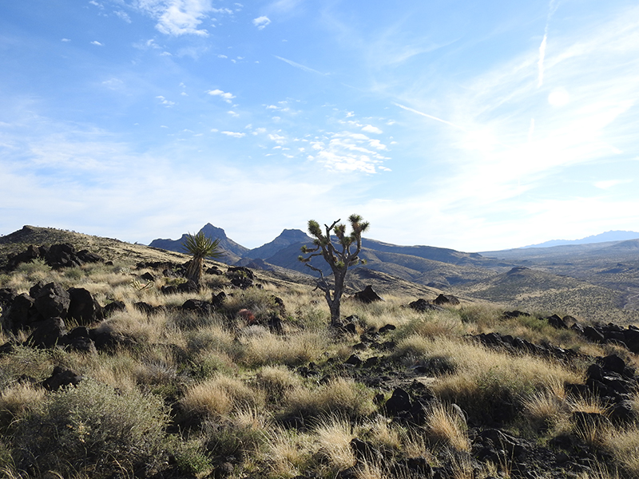

^Castle Mountains, Nevada. Site of a meteorological tower for a proposed wind project.

November 30, 2018 - Southern Nevada - **UPDATE** - The Las Vegas Review-Journal interviews Basin and Range Watch and confirms with BLM that the project is canceled: https://www.reviewjournal.com/news/politics-and-government/blm-rejects-massive-wind-farm-along-california-nevada-border-1539541/

The Department of Interior canceled the Crescent Peak Wind Project in southern Nevada next to Castle Mountains National Monument and South McCullough Wilderness Area, the Bureau of Land Management (BLM) confirms to Basin and Range Watch. Thanks to a large local grassroots push to halt this ill-sited wind project and protect the rare desert grasslands and biodiverse Joshua tree woodlands here. Interior cited recreational values of this area, mining and hunting, as well as the BLM's cancellation of its Southern Nevada Resource Management Plan. Historic resources, tribal concerns and archaeology were also concerns.

Our grassroots network helped write many letters to Interior Secretary Ryan Zinke telling him this area was a valuable area for recreation. Hunters wrote that this place was a significant area. Birdwatchers come here to see the unusual gilded flicker.

**The Reno state office of the Nevada BLM issued this statement today:**

"Here is the BLM statement regarding this project:

"The BLM is denying the right-of-way application made by Crescent Peak Renewables LLC for the proposed Crescent Peak Wind project near Searchlight, Nevada. The BLM had previously determined that the proposed project would not conform with the Las Vegas Resource Management Plan – a conflict that in many cases results in immediate rejection of project proposals. Nonetheless, the agency conducted a significant public scoping process and engaged a number of cooperators, including Federal, county, and state governments, to provide information on potential project impacts. This review, however, identified multiple issues and concerns that prompted the agency’s decision to deny the application.

"These issues include that access to the turbines would potentially affect the development of more than 300 mining claims; the turbines could interfere with radar at two regional air facilities – one military and one civilian; and impacts to the visual landscape."

Rudy Evenson  
Acting Chief of Communications  
Bureau of Land Management - Nevada  
Office: 775-861-6629 Cell: 775-223-3158  
revenson@blm.gov | www.blm.gov/nv  
Follow BLM Nevada on Social Media

# Crescent Peak Wind Project to Start Review on Border of Castle Mountains

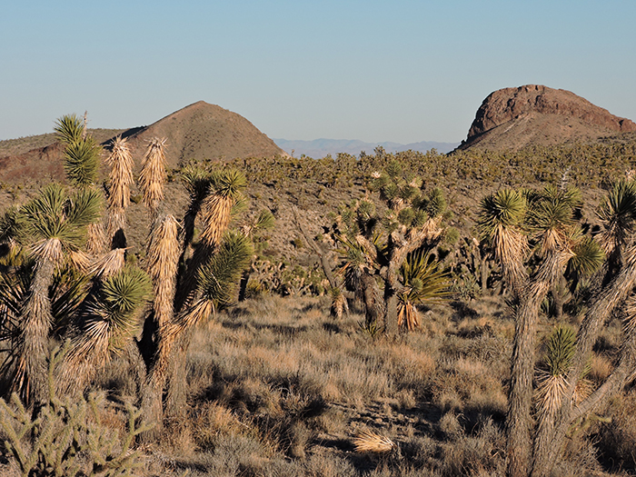

^No place for a wind project: border of Nevada and California with Joshua trees and desert grassland, next to Castle Mountains National Monument.

March 15, 2018 - Southern tip of Nevada - The 32,000 acre Crescent Peak Wind Project, located right on the border of Mojave National Preserve and the new Castle Mountains National Monument is now undergoing a 90 day scoping period in the Federal Register. Notice of Intent here: https://www.gpo.gov/fdsys/pkg/FR-2018-03-15/html/2018-05273.htm

The impacts to the scenery will be significant, so that the Bureau of Land Manageent (BLM) will need to downgrade the Visual Classification to approve the project.

We have submitted a nomination to the BLM to designate the entire project site as an Area of Critical Environmental Concern. This will be looked at under the review for the Southern Nevada Office Resource Management Plan.

# Crescent Peak Wind Proposal Pushed Ahead by BLM

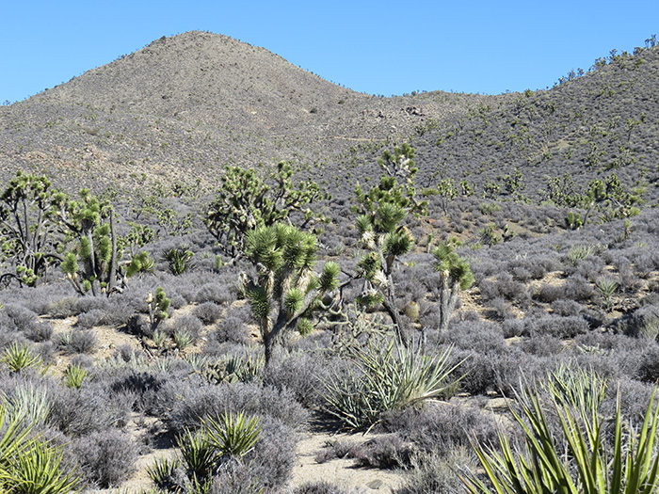

^Crescent Peak Hills, Nevada, site of a prposed wind project. This is adjacent to the new Castle Mountains National Monument.

May 14, 2017 - According to documents obtained by the Freedom of Information Act (FOIA), the Bureau of Land Management (BLM) is putting out a supplemental Environmental Impact Statement (EIS) for the Resource Management Plan but will not consider the wind free request. The EIS would cover wilderness study, Areas of Critical Environmental Concern (ACEC's), solar energy, land disposal, Gold Butte, and socioeconomics. Basin and Range Watch sent in a request to BLM to examine a wind-energy-free zone in the Searchlight and Piute Valley region, accompanied by a petition with over 700 signatures. The Colorado River Indian Tribes also requested this. We believe it is legitimate for BLM to cover it in a Supplemental EIS.

There is a draft Notice of Intent (with mineral segregation) and BLM has a Press Release ready to go with no date on it were obtained as part of the FOIA documents we obtained. There is also a raptor survey indicating the area is full of eagles.

Here is the BLM Press Release ready to go:

BLM Nevada News  
Southern Nevada District Office   
FOR IMMEDIATE RELEASE: [INSERT DATE], 2016  
Contact:Hillerie Patton, (702) 515-5046, hillerie_c_patton@blm.gov

**BLM Seeks Comments for Crescent Peak Wind Project Near Searchlight**

Las Vegas—The Bureau of Land Management (BLM) Las Vegas Field Office is seeking comments on the Crescent Peak Wind energy project proposed west of Searchlight, Nevada. The project would be built on approximately 32,531 acres of Federal land managed by the BLM.  A Notice of Intent to Prepare an Environmental Impact Statement was published in the [INSERT DATE] Federal Register.

The Las Vegas Field Office will prepare an environmental impact statement (EIS) for the project.  Publication of the notice in the Federal Register initiates the beginning of the scoping process to identify issues. Scoping meetings will be announced at least 15 days in advance through local media and on the BLM website at www.blm.gov/nv.

The public is being asked to comment on Crescent Peak Renewables, LLC’s (CPR) proposal to construct, operate, and maintain a 175 to 500-megawatt (MW) wind generation facility. The point of interconnection would be at either the proposed Nipton substation to connect with the existing Southern California Edison Eldorado-Mojave 500-kV transmission system or to the proposed RWITZ substation to connect to the Valley Electric transmission system. CPR has worked with the California Independent Systems Operator (CAISO) on plans for interconnection and delivery of energy into the California market.

Written comments may be mailed to the BLM, Southern Nevada District, Renewable Energy Project Manager, 4701 N. Torrey Pines Drive, Las Vegas, NV 89130, or emailed to xxxxEIS@blm.gov**.**For more information, please call Greg Helseth at (702) 515-5173.   
-BLM-

# Wind Project Moving Forward

April 23, 2016 - Crescent Peak Wind Project Update: Eolus Wind has submitted a Draft Notice of Intent (NOI) for the Crescent Peak Wind Project to be reviewed by the Bureau of Land Management. An NOI is the first stage of an official federal review of a big project like this. The BLM has placed the NOI on hold until October 1st, 2016 due to other large pending projects including a land exchange with Nellis AFB. But we could be engaged in this issue this coming fall.

The Crescent Peak Wind Project would be built on Nevada public lands and be adjacent to the Mojave National Preserve and the new Castle Mountains National Monument in California. It would surrond the historic Walking Box Rance and be visible from Searchlight, Nevada. A wind project surrounding Searchlight has been held up due to golden eagle and other wildlife threats.

# Digital Imagery of Proposed Crescent Peak Wind Project

March 6, 2016 - Thanks to Shaun Gonzalez for creating these digital images of the proposed wind project from different angles. The 3D turbine model I use is 146 meter hub height, which is consistent with a 3.3MW Vestas turbine.

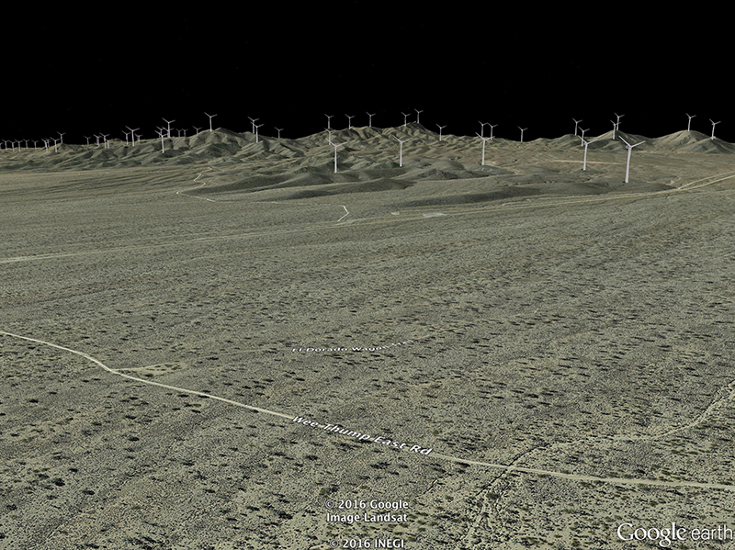

^Looking at the proposed wind project right of way from Wee Thump Joshua Tree Wilderness Area.

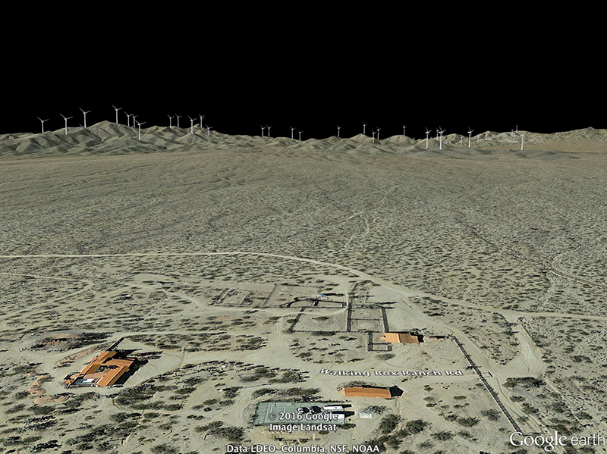

^Looking west from Walking Box Ranch.

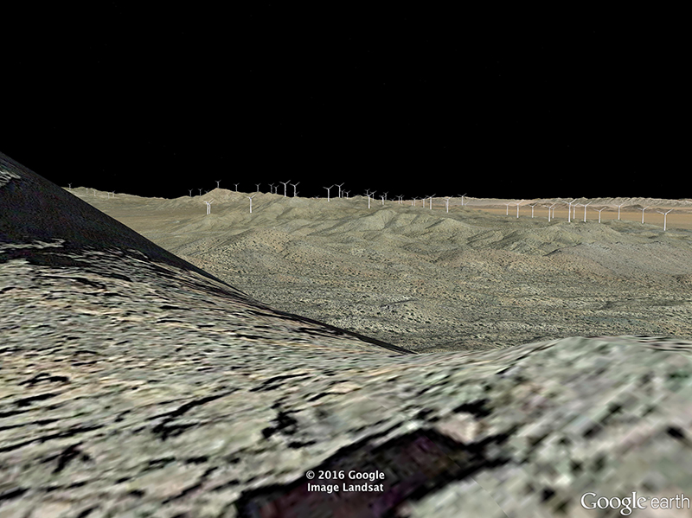

^From the Castle Peaks within the Mojave National Preserve looking roughly northeast into Nevada.

# Reactivated Wind Project Threat to Castle Mountains Area

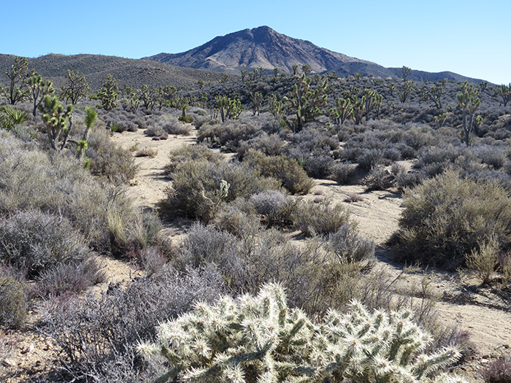

^Crescent Peak in the northern part of the New York Mountains, just outside the boundary of the Mojave National Preserve and adjacent to the proposed Castle Mountains National Monument. This scene is in the heart of a large industrial wind project application which has been reactivated.

February 5, 2016 - Clark County NV - Will there be a wind project next to the proposed Castle Mountains National Monument and Mojave National Preserve? Ironically, the new Castle Mountains National Monument in California, which may be created soon, has a reactivated wind energy application right next to it in Nevada. Eolus Wind has bought the applications for the Crescent Peak Wind Project (and Comstock Wind to the north near Virginia City, NV) and intends to file a Notice of Intent to prepare an Environmental Impact Statement with the Bureau of Land Management soon. The application spans nearly 40,000 acres and would be visible from the Castle Peaks, Wee Thump Wilderness, Walking Box Ranch, several Parts of the Mojave National Preserve, and Spirit Mountain. Eolus is saying they may want to use the newer 750 foot concrete based turbines which would be highly visible form the Mojave National Preserve.

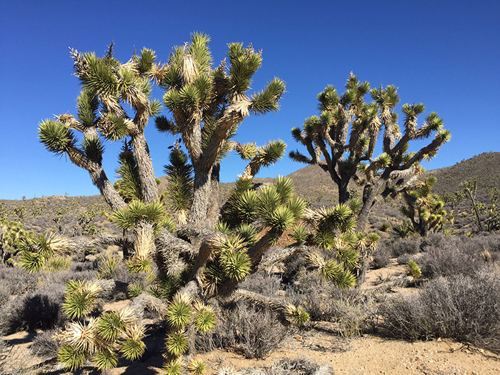

^Joshua trees (Yucca brevifolia) on the wind project site.

The wind proposal would be visible from Nipton, surrounded by the Wee Thump Wilderness and would border the Mojave National Preserve, all hugging the Nevada border. The Bureau of Land Management is expecting a revised plan of development and the company will be undertaking raptor surveys.

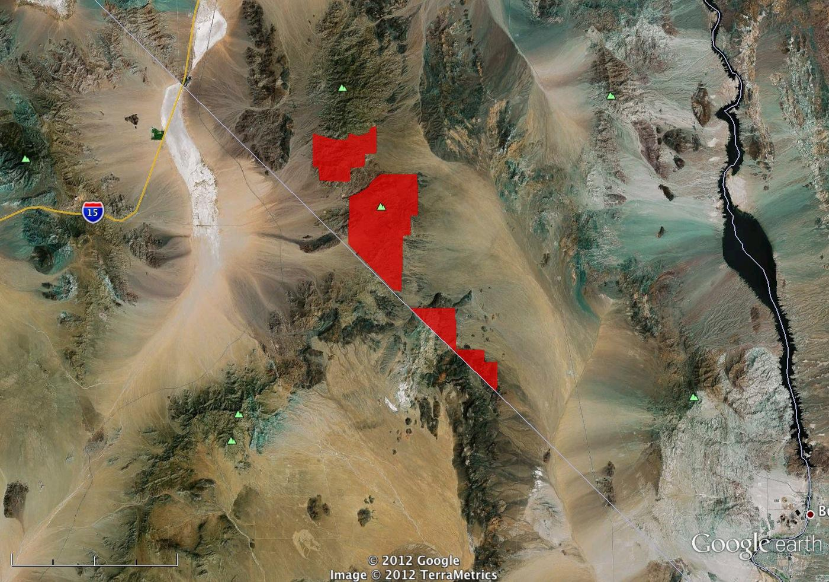

^Map of proposed Crescent Peak Wind Project in 2012, by Mojave Desert Blog.



^Joshua trees and yuccas (Yucca schidigera and Y. baccata) grow in a dense blackbrush (Coleogyne ramosissima) scrubland by Crescent Peak.

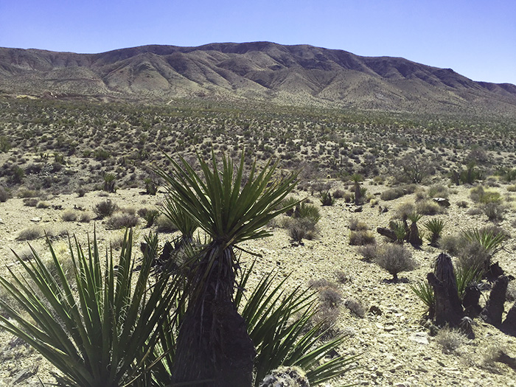

^Mojave yuccas dot the landscape on the west slope of the northern New York Mountains where the wind application sits. Nipton is within view of this landscape. Looking south from the Nipton-Searchlight road.

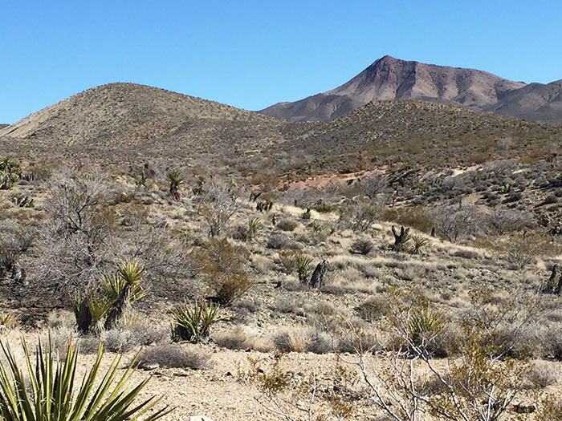

^Crescent Peak with blackbrush, Mojave yuccas, catclaw acacias ( Acacia greggii, leafless in winter), and big galleta grass (Hilaria rigida).

The Swedish company Eolus just reactivated a dormant application from Oak Creek Wind and have not yet started the environmental review process.

In order to get the NOI in the Federal Register, they need to submit an updated Plan of Development to BLM which they have not done yet. It will take BLM about 2 months to decide if the plan will will be good enough to start National Environmental Policy Act review.

The project is about 40,000 acres, however, the new owner is saying the final project will be anywhere from 50 to 200 MW.

Standard turbines (450 feet tall) may be considered outdated technology. The utilities are far more interested in photovoltaic solar projects. So this company wants 4 megawatt turbines which would be 750 feet tall. There is a demonstration project using these in Iowa, and we have seen on at Tehachapi Pass in CA. This would be an even larger visual intrusion to surrounding landscapes than older large wind turbine generator models.

Eolus told BLM it would take five years to complete all surveys and they would not start construction until 2021.

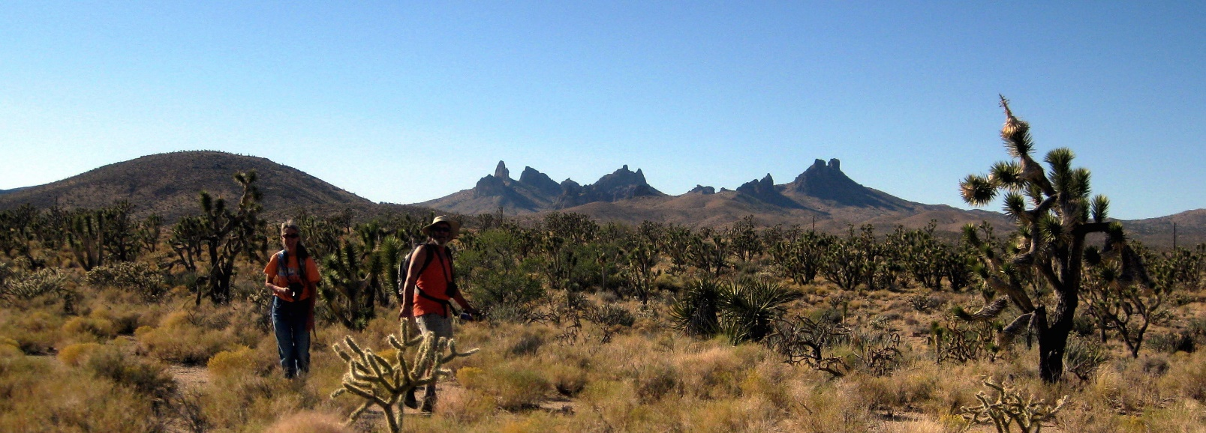

^Laura Cunningham of Basin & Range Watch is on the left in this photo by Campaign for the California Desert, helping to write letters to Congress to preserve the area in 2009. Castle Mountains is just to the south of the proposed wind project.

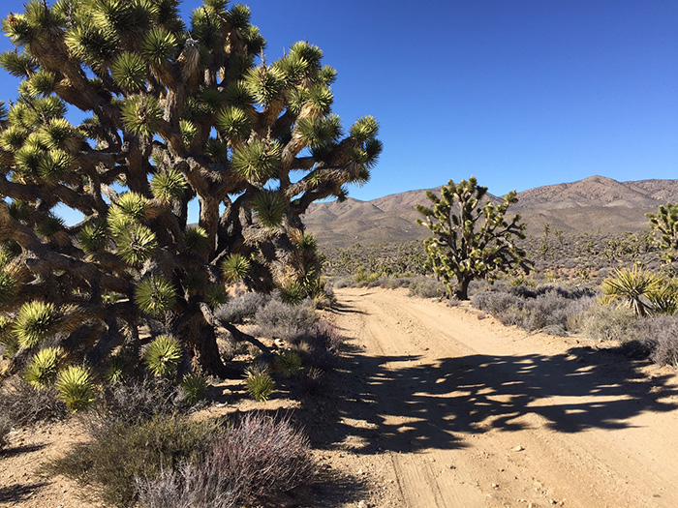

^Public access dirt road on BLM land on the Crescent Peak wind project site; this road would need to be widened for construction traffic. The wind project would also possibly sit on the distant foothills of the McCullough Mountains in the background.

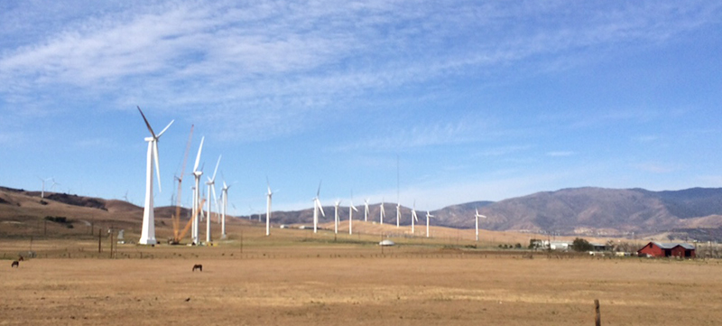

^Very large wind turbine generator on the left under construction on Tehachapi Pass CA, which may be similar to the design sought by Eolus at the Crescent Peak area. These would be visible from a huge distance away.

The BLM said that they may want to use less turbines due to the super size of this new mega-concrete turbine. Eolus told BLM there could be as few as ten for this project. The question is where would they put a small project in that 38,000 acres? Possibly around Crescent Peak. It is full of patented mining claims and active mines, and BLM would consider that the most disturbed area. But even at 4 MW, ten would only give them 40 MW.

The Las Vegas Resource Management Plan noted that the Piute Valley (east of Crescent Peak) should be managed for its solitude and primitive recreation opportunities.

Here is the promotional link: http://nawindpower.com/eolus-acquires-two-nevada-wind-power-projects

Through its recently established North American subsidiary, Sweden-based developer Eolus has acquired two wind power projects under development in Nevada. The transaction means that Eolus will acquire 100% of the shares in the U.S. companies Crescent Peak Renewables LLC and Comstock Wind LLC for the sum of $50,000.

According to Eolus, Crescent Peak owns the rights to a project between 200 MW and 600 MW under development in Clark County, and Comstock owns the right to a project between 20 MW and 100 MW under development in Storey, Washoe and Carson City counties. The transaction includes a profit sharing mechanism for the future sale of the wind projects.

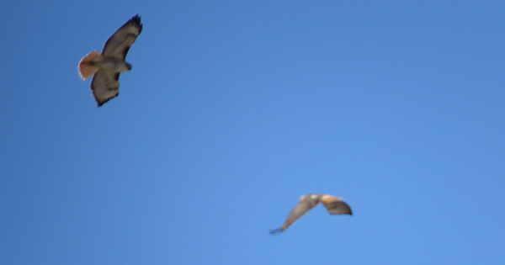

^Two red-tailed hawks wheeling in the skies above Crescent Peak during our visit.

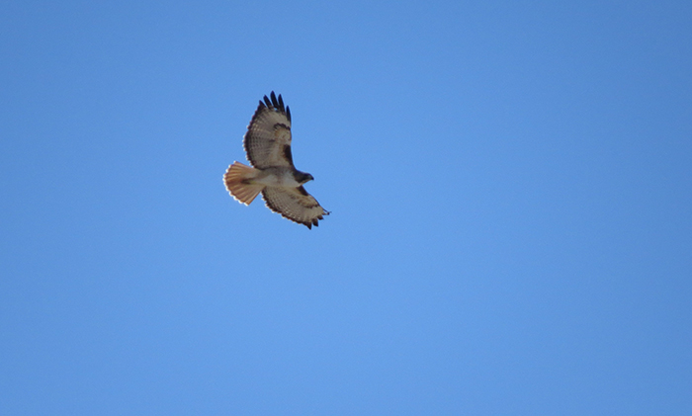

^Red-tailed hawk in the Crescent Peak area.

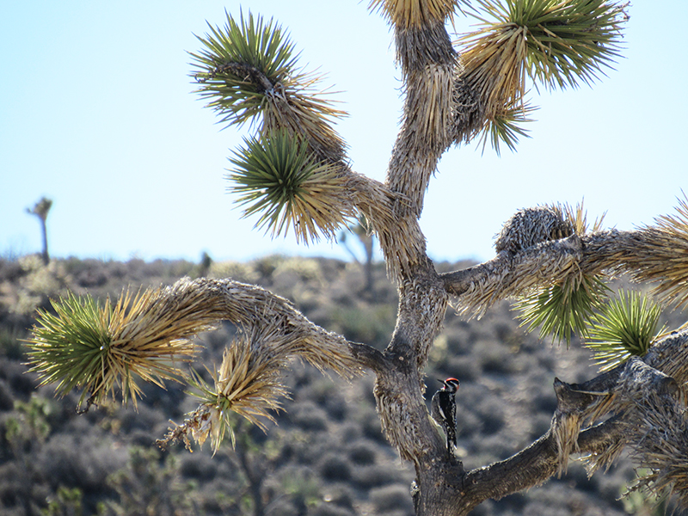

^Red-naped sapsucker on a Joshua tree in the wind project proposal site, Crescent Peak area.

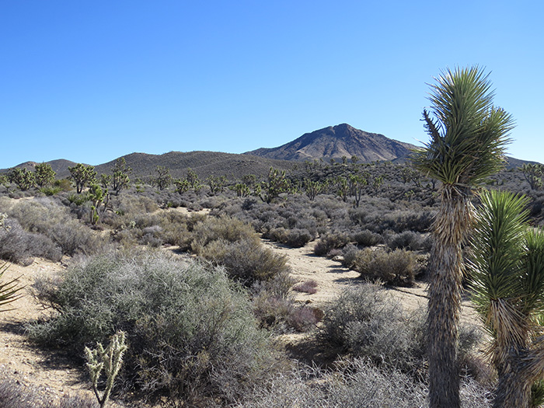

^Crescent Peak with a wash lined with desert almond (Prunus fasciculata) and Apache plume (Fallugia paradoxa).

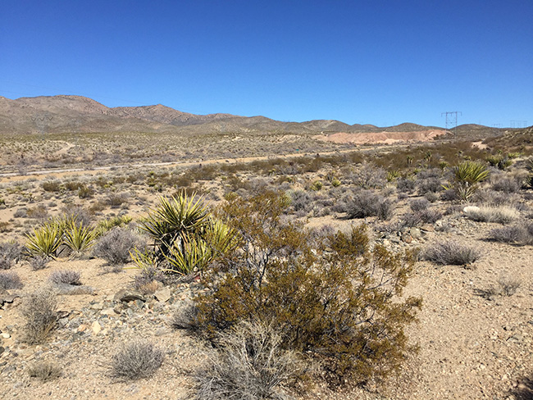

^Highway connecting Nipton and Searchlight cuts through the wind application which would lie on either side if following the prior application. A transmission line is probably the main reason wind developers find this site attractive.

^Looking west from the northern New York Mountains and highway to Ivanpah Valley and Clark Mountain. The glowing Ivanpah solar power towers are visible in the distance.

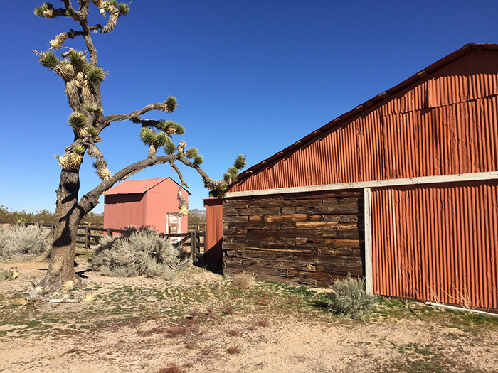

^Historic Walking Box Ranch, managed by the BLM, lies on the eastern edge of the proposed wind project.

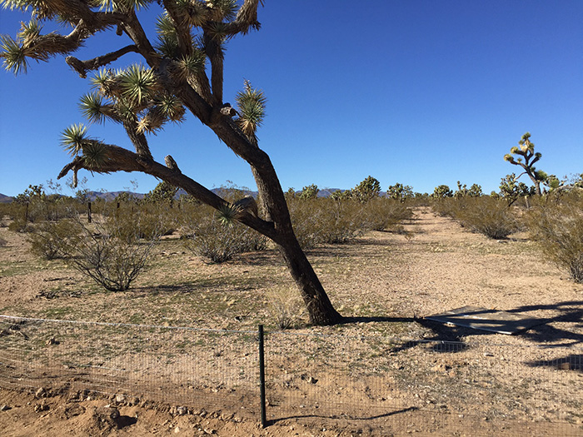

^Desert tortoise exclusion fence on Walking Box Ranch, looking westward to the Crescent Peak hills where the wind project might lie. The area is managed for tortoises in the Pauite Eldorado Valley.

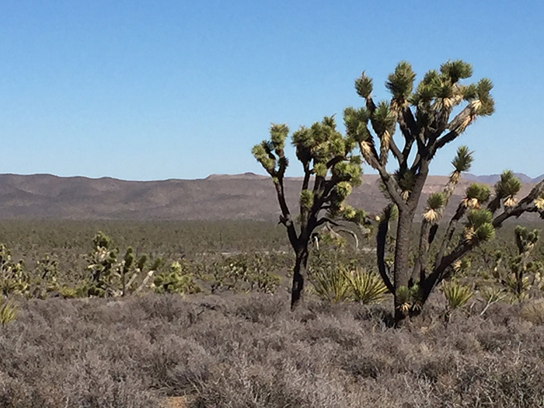

^Blackbrush and Joshua Trees on the lower hills of the proposed project site, looking towards Wee Thump Joshua Tree Wilderness.